Transport layer protocol header analysis using Wireshark- TCP

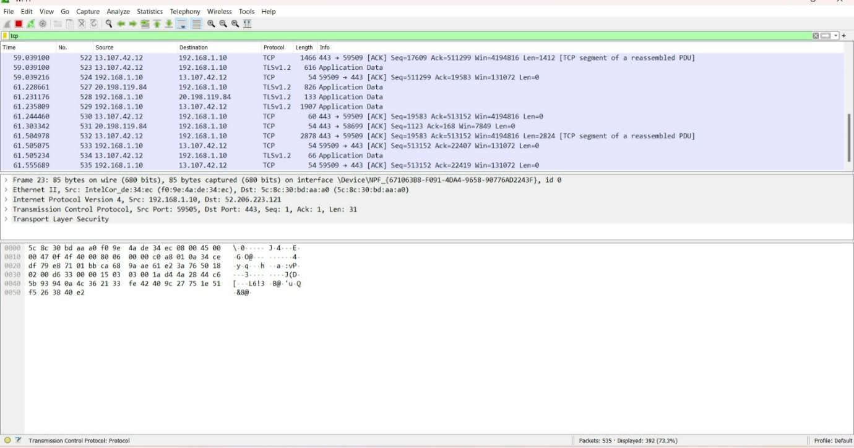

Network layer protocol header analysis using Wireshark - SMTP

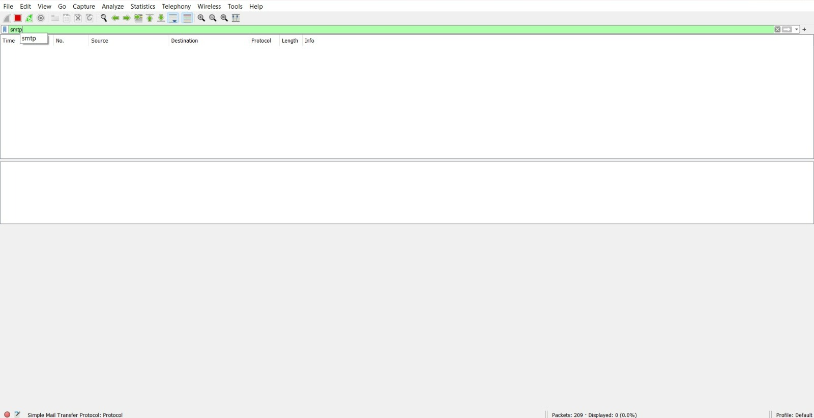

Network layer protocol header analysis using Wireshark - ICMP

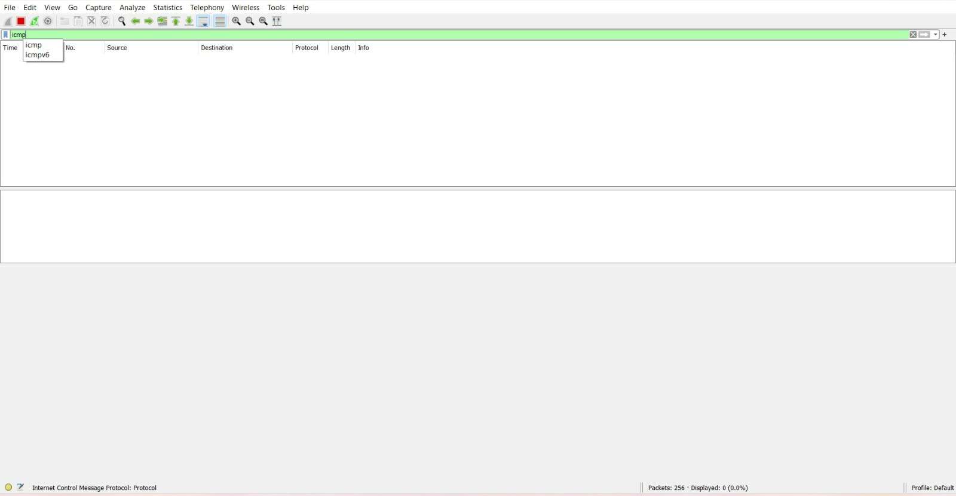

Transport layer protocol header analysis using Wireshark - UDP

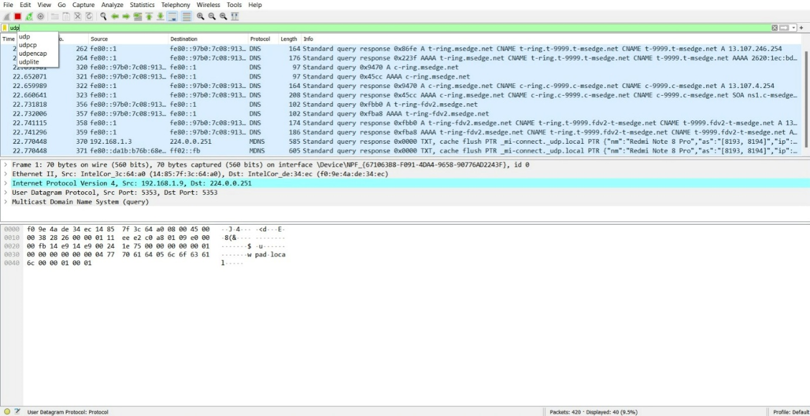

Network layer protocol header analysis using Wireshark - ARP

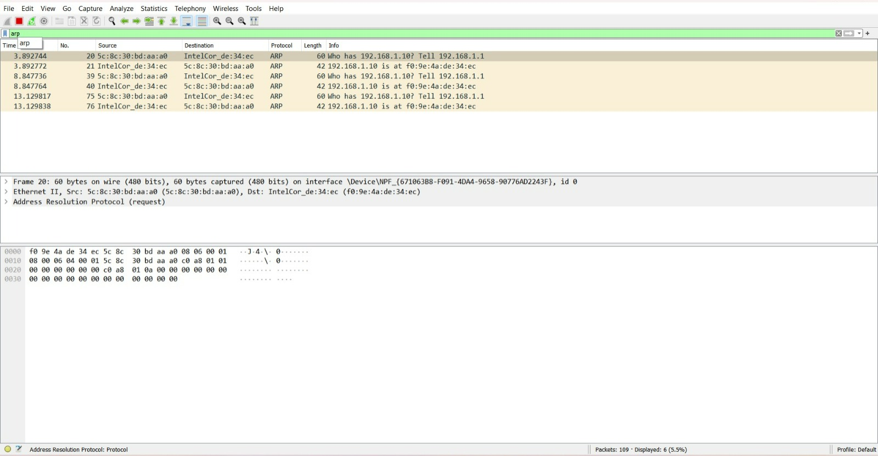

Network layer protocol header analysis using Wireshark - HTTP

